Google Classrooms – For Parents and Carers
You will receive your child’s log-in details within the next few days. You will then need to log-on as follows:
For example
User Name: dirk@westcliffeprimary.com
Password: school88!

- When you have these details search for Google Classrooms or use the link in the text message. http://classroom.google.com/
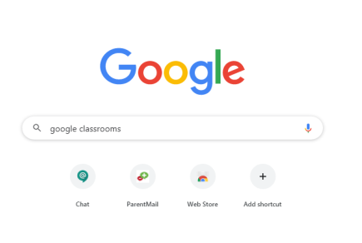

- When you are into Google Classrooms sign in with your child’s details. Press next.
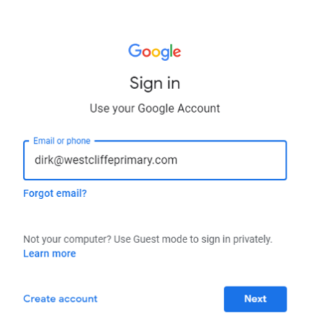

- Type in the password – make sure uppercase and lowercase letters are in the correct places and no spaces. 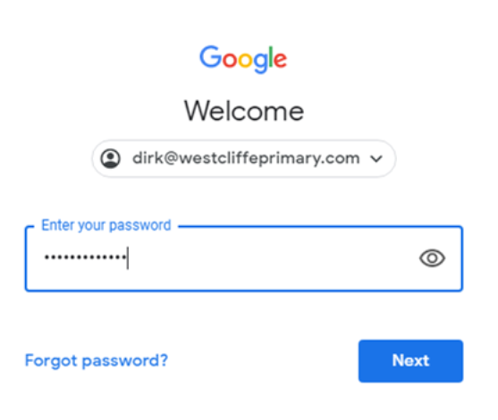

- Accept the terms and conditions and then you will see an image like this – click continue

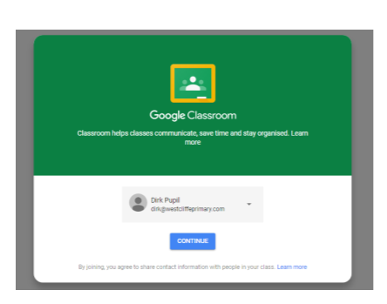

- Click your role as a student
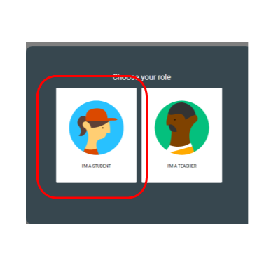
- Join your class
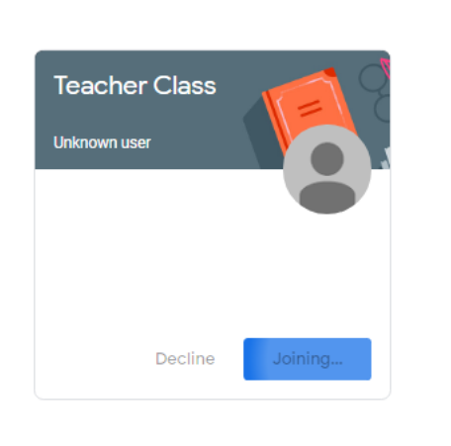
- Click on the classwork tab at the top and each day work will be posted for your child.
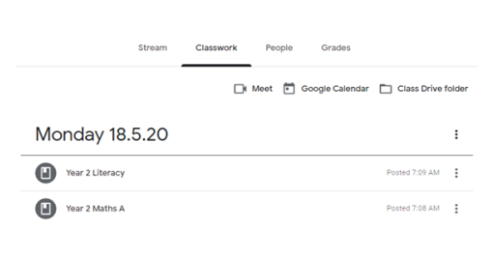

- Click on the subject or the documents of work.
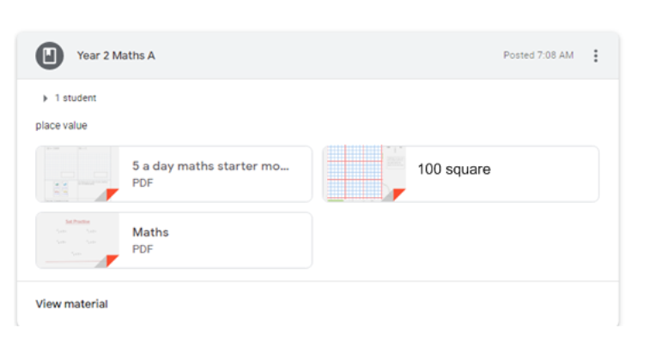
- Click on the work and complete the questions at home either on paper or you may collect an exercise book from school.
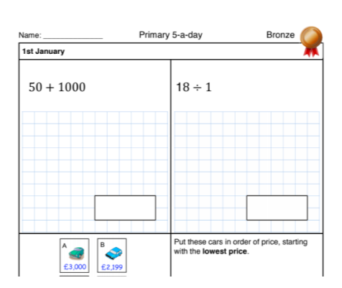

You can press the back arrow and return to the classwork and repeat the process – click on other documents to view the work and complete at home.

- Finally if you need to speak to your child’s teacher, regarding support for the work, you can comment below the documents and the teacher will respond at some point in the school day. Click on the tab Stream, click on the document and then comment underneath.


